ASSIGNMENT 1

Minh Nguyen

104309099

COS30045: DATA VISUALIZATION

Swinburne University of Technology

Word Count: 2134

## Outline

Outline 2

Introduction 3

Figure 1: Current expenditure by medical services, medical goods, and collective care, 2003 4

Analysis 4

Critique 4

Real-life context 5

Figure 2: Life expectancy at birth and health spending per capita 6

Analysis 6

Critique 7

Real-life context 8

Figure 3: Resistance trends of Gram-positive cocci isolated from general hospitals 9

Analysis 9

Critique 9

Real-life context 10

Conclusion 11

Appendix 12

Source of Charts 12

References 12

# Introduction

Data visualization is essential for analyzing information and decision-making. It offers an accessible way to view and understand charts, trends, and patterns in data. Therefore, a good understanding of data visualization principles and guidelines is necessary to convey data to readers.

This report aims to offer insight into the aspects of the three graphs, including their data points, design, key features, and flaws in design that do not comply with the design guidelines. This report starts with an introductory overview highlighting the importance of data visualization principles and the objective of this report. After that, a deep analysis and critique of each chart will be presented, where both advantages and disadvantages are thoroughly analyzed and critiqued. Next, the conclusion of this report lists some of the common flaws of these graphs and a brief comparison of the types of charts used for these. Lastly, an appendix for the references includes sources of graphs and articles to support this report.

# Figure 1: Current expenditure by medical services, medical goods, and collective care, 2003

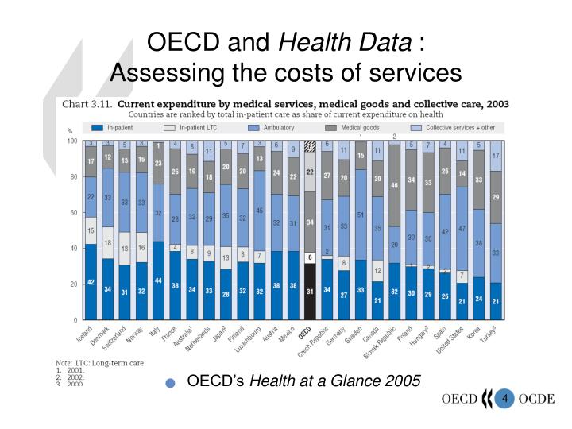

**Current expenditure by medical services, medical goods, and collective care, 2003**

## Analysis

The chart titled "Current Expenditure by Medical Services, Medical Goods, and Collective Care, 2003" provides a comprehensive overview of the allocation of healthcare expenditures within various countries based on the specific segments of the healthcare system. Each country is represented by a stacked bar chart, where each part of the bar signifies the percentage of spending allocated to it out of the total healthcare expenditure.

## Critique

The data is categorized and color-coded, making distinguishing between different types of expenditures easy. However, the value for the ambulatory in the chart is blurred, so a darker color for the bar and a lighter color for the value should be considered for better illustration and better contrast. Different symbols like stripes could be used for differentiation.

Stacked bars allow for a direct comparison of total expenditures across countries and a breakdown within each country. However, comparing specific categories across countries can be challenging as the order of the bars and the range of categories vary in size.

A more comprehensive label for the y-axis could improve clarity. Instead of "Total in-patient care share of current expenditure," it could be relabeled as "Percentage of health expenditure by category." The x-axis for the countries could be more apparent since it presents too many countries at once. Increasing the size of the chart could be a key to the problem.

The given data is from 2003. Including more recent data to reflect the current healthcare context would be more beneficial. Besides, the data of each country is not synchronized. For example, the data from Australia is from 2001, Japan and Hungary are from 2002, and Turkey is from 2000. The unsynchronized data means that comparing the proportions of health expenditure among the countries could be inaccurate. Data values from the same year should replace the unsynchronized data to suit the year stated in the chart.

Gridlines could be incorporated into the existing design to help prevent visual confusion and provide precise context for where each category of healthcare expenditure stands in its percentage rate.

Suppose the chart aims to make fair comparisons between countries with different population sizes or economic conditions. In that case, it might be helpful to normalize these expenditures by presenting them per capita or as a proportion of the country's Gross Domestic Product (GDP).

Making the chart interactive allows users to focus on specific parts of the data that interest them. For instance, a user could click on a type of expenditure to sort the countries by continents or economic terms (developed, developing, underdeveloped, and newly industrialized countries)

## Real-life context

This chart can help governments learn how they allocate healthcare funds compared to other governments. It can guide decisions about where more funding is needed. For example, if a country spends a large proportion on in-patient care, it might need to invest more in preventive measures to reduce hospital admissions. This data could be used to study the effect of spending patterns on health results.

# Figure 2: Life expectancy at birth and health spending per capita

**Life expectancy at birth and health spending per capita**

## Analysis

The scatter plot "Life expectancy at birth and health spending per capita" visualizes data from 2015 (or the nearest year). It shows the correlation between health spending per capita (thousand USD PPP) and life expectancy at birth (years). Each data point, indicated by a triangle on the graph, represents a country with its respective abbreviations. A trend line indicates a positive correlation between health spending per capita and life expectancy at birth. The R² value of 0.54 is indicated at the bottom right corner, indicating that around 54% of the variance in life expectancy could be explained by healthcare expenditure per capita. Overall, developed countries such as the USA (having the highest health expenditure per capita) and Japan (the highest in life expectancy) are superior to developing countries like India and Indonesia (the first and second lowest subsequently in health expenditure per capita and life expectancy) in both terms of the chart.

## Critique

The title is straightforward and gives an idea about the data represented. However, it could be more descriptive by including the year of the data or the geographical area it covers. For example, the title could be "The Correlation between Health Spending per Capita and Life Expectancy at Birth in 2015 (or Nearest Year) in Multiple Countries”.

Both axes contain their respective variables and their measured unit. However, the range of the x-axis (0 to 10 thousand USD PPP) and y-axis (65 to 85 years) could be adjusted to better fit the data points and provide a more detailed view. The lines in the background, which represent the specific value of life expectancy, could be replaced by the grid line for the y-axis to match the grid line of the x-axis and better read the value.

The triangle effectively represents individual data points. However, using a color scale or different symbols could help distinguish between different groups within the data, and legends could be used to explain what each symbol or color scale means. For instance, the countries could be distinguished based on economic terms (developed, developing, underdeveloped, and newly industrialized countries) or geographical areas, which also helps compare the amount of health expenditure and the life expectancy among the groups. Also, increasing the padding among data points or the chart size could be a solution for better readability and illustration. Data interaction could be used to sort data based on different aspects to specify the needed data value.

The trend line helps understand the overall pattern of data distribution. However, if the countries are categorized into different groups, different trend lines could be used to demonstrate different trend patterns and compare with each other.

The country abbreviations might be unclear to some viewers, as only some know these abbreviations. Therefore, full country names or legends could be included beside the chart to enhance readability. Another way is to create data interaction so that when the mouse hovers over a country, the full name for it could appear.

The data in this chart is from 2015 or older, nearly a decade ago, so replace the old data with the current one to demonstrate the trend during current years.

## Real-life context

This chart can help governments learn how they use healthcare expenditures compared to others. It can guide decisions about where more funding is needed. Also, countries with low expenditures and low life expectancy can cooperate with other countries to boost health outcomes, increasing the importance of international cooperation in health.

# Figure 3: Resistance trends of Gram-positive cocci isolated from general hospitals

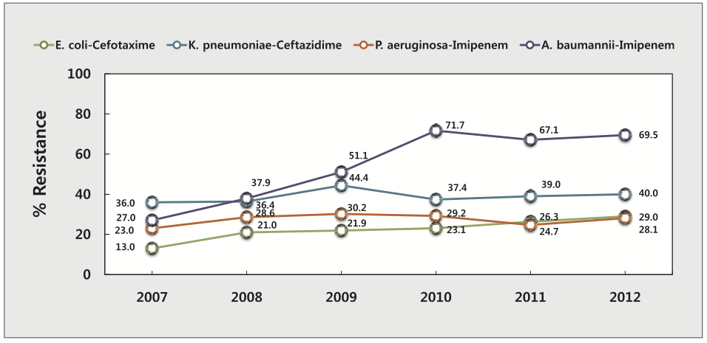

**Resistance trends of Gram-positive cocci isolated from general hospitals**

## Analysis

The line graph titled “Resistance trends of Gram-positive cocci isolated from general hospitals” depicts the percentage of antibiotic resistance over the years (from 2007 to 2012) for four different combinations of bacteria and antibiotics. A distinct color represents each combination trend line. The y-axis represents % resistance (0 - 100%), and the x-axis represents time (2007 – 2012). Each data point on the lines contains percentages showing specific resistance values each year.

## Critique

The title clearly states the data in the chart. However, it could be more detailed by including the range of years of the data and the geographical area it covers. For example, it could be changed to “The resistance trends of Gram-positive cocci isolated from general hospitals from 2007 to 2012 in Korea."

Both axes are appropriately labeled, but the y-axis label could be more descriptive, for example, "Percentage of Antibiotic Resistance (%)." Moreover, the grid lines for the axes could be highlighted to help show specific data values and the grey background of the chart should be removed. Instead, the white background can make the grid lines more transparent and increase the chart size to fit the box.

The data points are marked, and using different colors for each bacterium-antibiotic pair aids in differentiation. However, data points for different countries could also be added for comparison and differentiated using different shapes.

The labels showing the exact percentages at each data point are helpful but make the graph look cluttered. Removing some labels or increasing the graph’s size are great solutions. Data interaction could also be a good choice because the value will appear when the users hover the mouse over the data points.

The latest data points in this chart are from 2012, more than a decade ago, so the current value could be added to demonstrate the trend during current years.

## Real-life context

The increasing trend in antibiotic resistance shown in the chart is a significant public health concern. As bacteria become more resistant to antibiotics, infections become more challenging to treat, leading to higher medical costs, extended hospital stays, and more deaths.

Understanding the trend of antibiotic resistance is crucial for choosing the right treatment strategies. When a type of bacteria is known to be highly resistant to a specific antibiotic, the pharmaceutical industry may boost research and development for alternative treatments. Governments can use this data to prioritize public health initiatives, such as campaigns to reduce unnecessary antibiotic use, a significant factor in antibiotic resistance.

### Conclusion

Some aspects of the health field have been explored throughout the analysis and critique of these graphs: the cost of medical services in Figure 1, the relationship between healthcare funding and life expectancy in Figure 2, and the percentage of resistance to some antibiotics in Figure 3. While conveying essential information to the readers, improvement in the design of the charts is necessary. For instance, the titles of the charts lack information like the period or the geographical areas; the limited use of different colors and shapes to indicate the data points; and the unnecessary features like the background or the box grid, which violate the data-ink ratio and decrease readability.

To avoid these mistakes, follow the design guidelines and use charts that suit the data types. For example, a stacked bar chart in Figure 1 helps compare different categories and see the composition of the total amount; a line chart in Figure 3 is commonly used to show trends over time, and a scatterplot in Figure 2 illustrates the relationship between two variables.

This report provides a comprehensive chart overview, covering all the data and design features. Based on these critiques, many essential health decisions could be made, helping to provide everyone with a higher standard of living.

### Appendix

### Source of Charts

Figure 1: R. (2014, January 4). PPT - Measuring health care quality at the international level: Progress in the OECD Health Care Quality Indicators Project PowerPoint Presentation - ID:1406264. SlideServe. <https://www.slideserve.com/rolando/measuring-health-care-quality-at-the-international-level-progress-in-the-oecd-health-care-quality-indicators-projec>

Figure 2: OECD Health Care at a Glance 2017: Since 2001, overweight has risen by more than 50% in the Czech Republic | Economic policy | Council on Czech Competitiveness. (n.d.). AmCham. <http://www.czechcompete.cz/economic-policy/health-care/oecd-health-care-at-a-glance-2017-since-2001-overweight-rose-by-more-than-50-in-the-czech-republic>

Figure 3: Team: Elan Vital Korea/Practices - 2015.igem.org. (n.d.). <https://2015.igem.org/Team:Elan_Vital_Korea/Practices>

### References

Raj, A. (2022, November 10). *Data-ink Ratio Explained With Example - Code Conquest*. Code Conquest. <https://www.codeconquest.com/blog/data-ink-ratio-explained-with-example/>

Oetting, J. (2023, June 8). *16 Best Types of Charts and Graphs for Data Visualization [+ Guide]*. <https://blog.hubspot.com/marketing/types-of-graphs-for-data-visualization>

Redirecting. (n.d.). <https://swinburne.instructure.com/courses/56073/pages/w2-topic-02-data-visualisation-design-guidelines-and-graphical-integrity?module_item_id=3793613>

ThoughtSpot, T. (2023, November 22). *6 most useful data visualization principles for analysts*. ThoughtSpot. <https://www.thoughtspot.com/data-trends/data-visualization/data-visualization-principles>